**Summary Of Chapter 6**

**What is Management**

Management is the coordination and administration of tasks to achieve a goal. Such administration activities include setting the organization's strategy and coordinating the efforts of staff to accomplish these objectives through the application of available resources.

**Ancient Management**

* Looks at the foundation of the concept of management where the activities and controlling of activities are being done by someone.

**Adam Smith**

* **Adam Smith** was the **first person** to identify **specialization and the division of labor as the main drivers of productivity.**
* **Job Specialization**( **To just look at what you are good at)**
* helps to improve and enhance the overall productivity of the individuals.

**Industrial Revolution**

* Looks at the modernization and changes to the current way things are being done in a particular industry.

**The Administrative Theory**

* - is based on the concept of **departmentalization**, which means the different activities to be performed for achieving the common purpose of the organization should be identified and be classified into **different groups or departments**, such that the task can be accomplished effectively.
* - this relates to **job specialization.**

**Quantitative management** makes use of computers and **mathematical techniques** to sift through statistics values.

**Scientific Management**

* Scientific management is a **theory of management that analyzes and synthesizes workflows.** Its main **objective is improving economic efficiency, especially labor productivity**. It was one of the **earliest attempts to apply science to the engineering of processes to** management.

**The Theory Of Scientific Management**

Created by Fredrick Winslow Taylor ( 1911)

Using scientific methods to define the “one best way” for a job to be done:

* Putting the right person on the job with the correct tools and equipment.
* Having a standardised method of doing the job.
* Providing an economic incentive to the worker.

**Taylor’s Four Principles of Management**

1. You create a new approach for the individuals work and this includes upgrading the way things are being done by replacing the old approaches with appropriate methods of things that are relevant to the expectation of the industry
2. You will need to select the individuals and provide them with the relevant training and teachings for them to be more competent in what they are doing now.
3. Provide the required guidance and assistance for the actual concept of science to be applied in the job correctly.
4. This will also look at the segregation of the work between the management and the staff where the right people are assigned the right positions in order to prevent mistakes and wastage of resources in the organization.

**Frank and Lillian Gilbreth**

* Aim towards **improving and increasing the workers productivity by reducing the wastage of movement energies** of the workers.
* This reduces the number of steps that is needed and improves the efficiency of how things are being done.
* Objective is to **increase the work performance** in the organization by **minimizing the wastage of energy.**
* Developed the **Micro chronometer** to time worker motions and optimise work performance

**\*\*Micro chronometer** is an instrument for measuring very small intervals of time



**How Do Today’s Managers Use Scientific Management?**

* 1. Use time and motion studies to increase productivity
  2. Hire the best qualified employees
  3. Design incentive systems based on output
* **Henri Fayol**
  + Believed that the practice of management was distinct from other organisational functions
  + Developed fourteen principles of management that applied to all organisational situations

**Fayol’s 14 Principles of Management**

1. **The division of work**is the course of tasks assigned to, and completed by, a group of workers in order to increase efficiency. Division of work, which is also known as division of labor, is the breaking down of a job so as to have a number of different tasks that make up the whole.
2. **Authority** is the legitimate power which one person or group possesses and practices over another
3. **Discipline** is the practice of training people to obey rules or a code of behaviour, using punishment to correct disobedience.
4. **Unity of command** provides that an employee is responsible to only one supervisor, who in turn is responsible to only one supervisor, and so on up the organizational hierarchy.
5. **Unity Of Direction** is a concept found in administrative management theory. The principle provides that there should be only one leader and one plan for a series of activities seeking the accomplishment of the same objective.
6. **Subordination of Individual Interest to General Interest"** means that the interest of the organization is above the interests of the individual and the group. It can be achieved only when managers in high positions in the organization set an example of honesty, integrity, fairness and justice.
7. **Remuneration** is the pay or other Financial compensation provided in exchange for an employee's services performed. A number of complementary benefits in addition to pay are increasingly popular remuneration mechanisms. Remuneration is one component of reward management.
8. **Centralisation** is the process by which the activities of an organisation, particularly those regarding planning and decision-making, framing strategy and policies become concentrated within a particular geographical location group.
9. **Scalar chain** is the formal line of authority which moves from highest to lowest rank in a straight line. This chain specifies the route through which the information is to be communicated to the desired location/person.
10. **Order is the arrangement** or disposition of people or things in relation to each other according to a particular sequence, pattern, or method.
11. **Equity** is the quality of being fair and impartial.
12. **Stability of tenure of personnel**is a principle stating that in order for an organization to run smoothly, personnel (especially managerial personnel) must not frequently enter and exit the organization.
13. **Initiative** is the ability to assess and initiate things independently.
14. .**Esprit de corps** is a French phrase for the morale of a group. Esprit de corps is a feeling of pride and mutual loyalty shared by the members of a group.

**Max Weber**

Developed a theory of authority based on an ideal type of organisation **(bureaucracy)\*\***

**Bureaucracy \*\***

a system of government in which most of the important decisions are taken by state officials rather than by elected representatives.

Focus on

1. **Division of Labor**

* Simple defined jobs which are broken down to smaller parts.

1. **Authority Hierarchy**

* Focus towards the chain of command within the organization.

1. **Formal Selection**

* Selection based on the technical and relevant experience for the mentioned position.

1. **Formal Rules and Regulations**

* Written procedures and standards which has been approved and to be followed by all.

1. **Impersonality**

* Focus on the standardizing of rules and control within the organization and there is no personality preferences given.

1. **Career Orientation**

* This looks at the managers being the qualified and experienced individuals who operate and manage the units assigned to them, but they do not own those units.

**Quantitative Approach**

* Also called *operations research* or *management science*
* Evolved from mathematical and statistical methods developed to solve WWII military logistics and quality control problems
* Focuses on improving managerial decision making by applying:
* Statistics, optimisation models, information models, and computer simulations

**Organizational Behavior (OB)** is the **study of human behavior in organizational settings**, the interface between human behavior and the organization, and the organization itself.

**Early OB Advocates**

* + Robert Owen (Late 1700)
    - Focus on the concern of deplorable working conditions and suggest idealistic work environment. Smart investment towards improving labour is justified
  + Hugo Munsterberg (Early 1900)
    - Focus towards the psychological testing towards the understanding of behavior and motivation aspects of the staff
  + Mary Parker Follett ( Early 1900)
    - Focus on being people oriented rather than scientific management
    - Looked at individual and group perspective
  + Chester Barnard
    - Believed a manager’s job was to communicate and stimulate best level of effort
    - First to argue that organizations were open systems

**Hawthorne Studies**

The Hawthorne effect is a type of reactivity in which individuals modify an aspect of their behavior in response to their awareness of being observed. This can undermine the integrity of research, particularly the relationships between variables.

* **Experimental findings**
  + Productivity unexpectedly increased under imposed adverse working conditions.
  + The effect of incentive plans was less than expected.
* **Research conclusion**
  + Social norms, group standards and attitudes more strongly influence individual output and work behavior than do monetary incentives.

**System Defined**

* + A set of interrelated and interdependent parts arranged in a manner that produces a unified whole.

**Basic Types of Systems**

* + **Closed systems**
    - Are not influenced by and do not interact with their environment (all system input and output is internal).
  + **Open systems**
    - Dynamically interact to their environments by taking in inputs and transforming them into outputs that are distributed into their environments

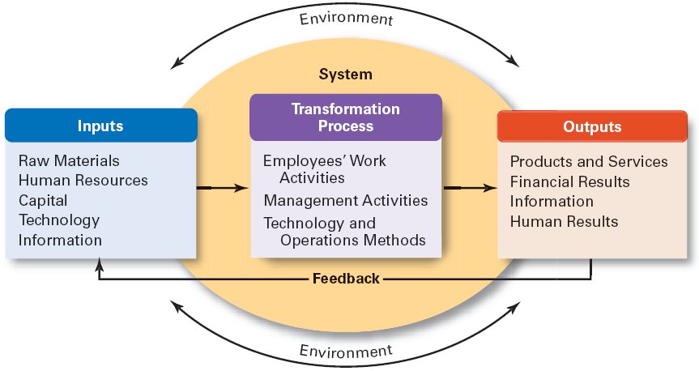

* **Contingency Approach Defined**
  + Also sometimes called the ***situational approach****.*
  + There is no one universally applicable set of management principles (rules) by which to manage organisations.
  + Organisations are individually different, face different situations (contingency variables), and require different ways of managing.

***Situational approach -*** This **approach** addresses a directive and a supportive dimension of leadership. Subordinates' need for direction and support can be high and can be how. Depending on such a need, leaders can determine how competent and committed when subordinates perform a certain task.

**Common Variable Used in Contingency Approach**

**Organisation size**

* + As size increases, so do the problems of coordination.

**Routineness of task technology**

* + Routine technologies require organisational structures, leadership styles, and control systems that differ from those required by customised or non-routine technologies.

**Environmental uncertainty**

* + What works best in a stable and predictable environment may be totally inappropriate in a rapidly changing and unpredictable environment.

**Individual differences**

* + Individuals differ in terms of their desire for growth, autonomy, tolerance of ambiguity, and expectations.